# Q. Distribution of attrition in the Train data?

# Q Logit Model?

## Model: Entire Train, Predict: Entire Test

Confusion Matrix

FALSE TRUE

No 233 10

Yes 34 17

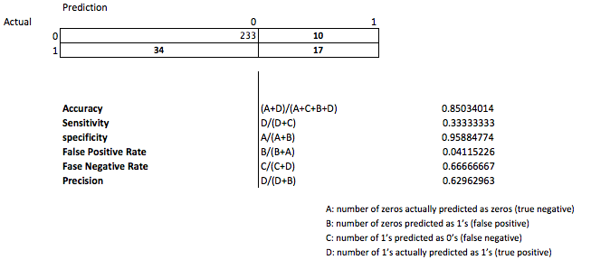

ROCR Curve

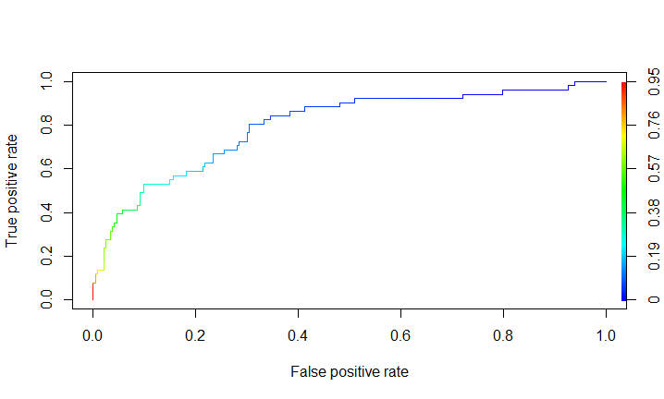

## Model: Sales Train, Predict: Sales Test

Confusion Matrix

FALSE TRUE

No 60 5

Yes 7 12

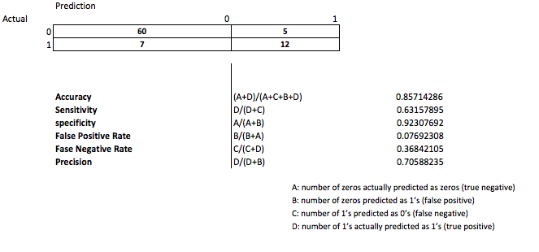

ROCR Curve

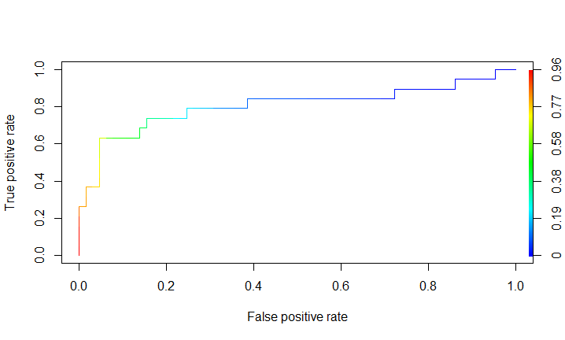

## Model: R&D Train, Predict: R&D Test

Confusion Matrix

FALSE TRUE

No 160 4

Yes 26 6

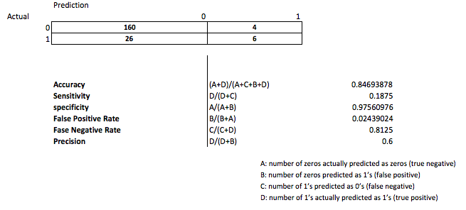

ROCR Curve

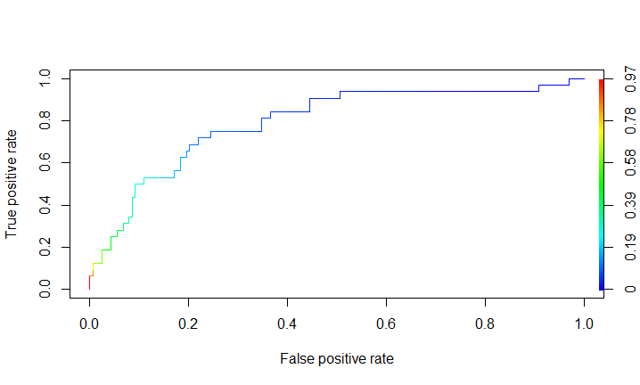

## Model: HR Train, Predict: HR Test

Confusion Matrix

FALSE TRUE

No 11 3

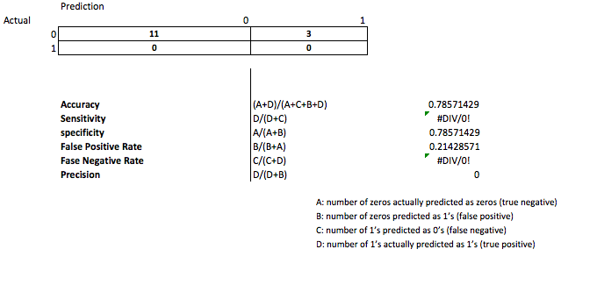

ROCR Curve